AMFA Expertise
Update as of July 2019
- Responsible Finance
Azerbaijan Micro-finance Association (AMFA) is a 15 years old country level microfinance association that has been grown over the last 1.5 decade time into one of the successful business associations in ECA region. Till date AMFA have been successful in development its credibility and professional expertise in various fields: Responsible Finance, Financial Education, Consumer Protection, Financial transparency, Financial Inclusion,
Responsible Finance has attracted attention of AMFA since 2009 as a result of aggressive lending launched by some of the downscaling banks in the country that caused disruption of credit culture within MFIs and their clients. As a lessons learned from crises happened in America and Europe AMFA launched preventive measures via implementing applicable projects, initiatives and consulting services.
Under its strategic pillar of Continuing Education AMFA team conducted numerous trainings, seminars, conferences and study tours in the country and abroad covering development, discussions and sharing lessons learnt on various aspects of responsible finance, mentoring of Financial Educators, networking with Financial Educators in Central Asia countries as well as in Central and Eastern Europe via various regional and international project activities.

1. Promotion of Responsible Finance via the platform of Annual Conferences:

Years | 2010 | 2012
Titles | Responsible Finance in Azerbaijan | Challenging Time: How to mitigate Risks?
Sessions on Responsible Finance | 1. Responsible Micro-finance. Financial Education and Client Protection  2. Role of Credit Beuroin Financial Markets  3.To what extend does Social Reporting and Social Ratings Genuinely Answer Investors’ Questions& | 1. Setting up adequate internal control systems  2. Client Protection in Micro-finance :Multiple Borrowing and over –indebtedness  3. Critical Role of women in Micro-finance: How can we make micro-finance useful for women  4. Financial Literacy: Challenges and opportunities  5. Developing a Country Wide Approach to Social Performance Measurement  6. Micro-finance –A Risky Business
Years | 2014 | 2016
Title | Innovative Practices to reach financial Inclusion: Learning from Peers experiences | New Opportunities on the Horizon. Translating Challenges into Perspectives!
Sessions on Responsible Finance | - Handling/Managing client Complaints and feedback of the financial service consumers  - How can Financial education help the poor take control of their life | - Seminar on “Good Management of Bad Loans” facilitated by EFSE Expert  - Access to Finance by micro entrepreneurs via healthy and responsible lending  - Financial Education for long –term Saving and Investment  - Digital Revolution and Financial Inclusion  - The Dilemma- Credit Risk or Foreign Exchange Risk Borrowing in Foreign Currency
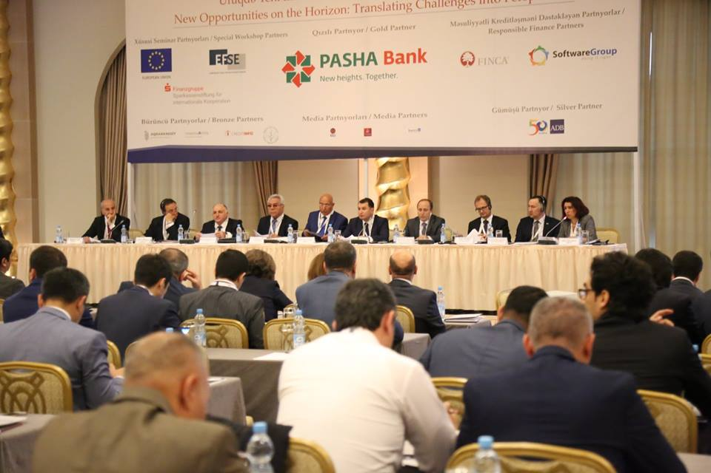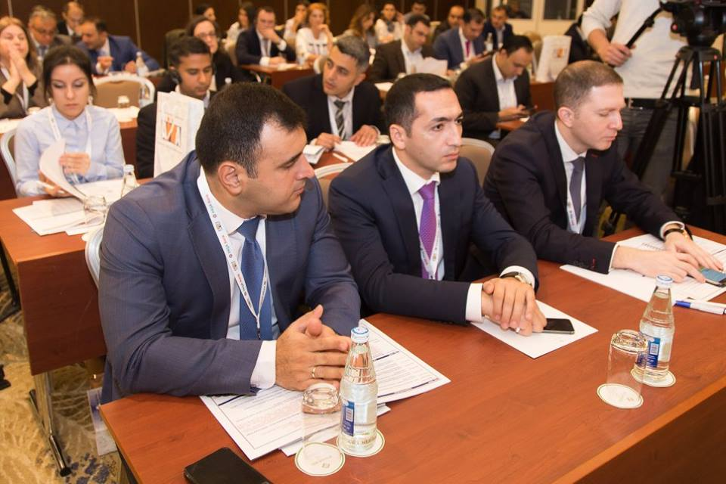

- Promotion of Responsible Finance via AMFA Annual Award Program

 | Year | Award Categories
1 | 2010 | 1.“Best MFI Employer of the Year”  2.“For exceptional contributions to improving living standards of the poorest clients”  3. “For Exceptional contributions to attracting investments into the microfinance sector in Azerbaijan”  4.“For exceptional contributions to availability of accessible and affordable microfinance services in the war-affected regions of Azerbaijan”
2 | 2011 | 1.“The Most Succesful Organization in Implementing its Social Mission”  2.“Best Organization for the 4 ^{th} Client Protection Principle of SMART Campaign: Ethical Staff Behaviour”  3.“Best innovative Product”
3 | 2012 | 1.“The Organization Supporting Micro-Business in Azerbaijan”  2.“The Organization holding the Best Customer Complaint Management Mechanism”  3.“The Organization promoting transparent pricing in micro-finance industry”
4 | 2013 | 1.“Effective Delinquency Management”  2.“Promoting Transparent Pricing in Microfinance Sector”  3.“Promoting Effective Corporate Governance”
5 | 2014 | 1.“The Effective Monitoring Employee Satisfaction Turnover"  2."The Effective Client Data Privacy System"  3.“The Effective Use of Innovative Technology”
6 | 2015 | 1."Advanced MFI in Agriculture and Rural development"  2. “Advanced MFI in Human resources management"  3."Advanced MFI in Educating its clients"
7 | 2016 | 1."Advanced MFI in building, sustaining client loyalty in post-crisis period"  2."Advanced MFI in increasing Financial Literacy of its clients"  3."Advanced MFI in Providing Digital Financial Services to its clients"
8 | 2017 | 1."Advanced MFI in the field of consumer rights' protection during repayment collection "  2."Advanced MFI in suggesting new product and services related to customer needs”  3."Advanced MFI in implementing complex trainings for officers' adaptation and motivation "
9 | 2018 | 1. “Advanced MFİ in building, sustaining client loyalty through Social Responsibility projects”  2. “Advanced MFİ in increasing Effectiveness through presenting the most Creative Loan product”  3. “Advanced MFİ in with better institutional Management during Economic Slow down”

Since 2009 till date under its strategic pillar of Innovative Products and Services AMFA team has been specialized in conducting different type of trainings & smart assessments including and not limited to financial education, social performance indicators, social performance management assessment, social performance audit, client protection principles assessment and other customized trainings targeting both staff of FIs as well as their borrowers. Such services were rendered to microfinance institutions, credit unions, downscaling banks in Azerbaijan and Georgia. AMFA was one of the first national networks in the region that expressed its interest in learning and upgrading its knowledge based on Responsible FInance during a weeklong training course on SPM organized by MFC in Warsaw on January 2005. Moreover, AMFA was successful in engaging participation of one of its member organizations- VF AzerCredit. Effective FY 2006 AMFA together with its member VF AzerCredit joined the Working Group on SPM and was proactively contributing to its work by regular participation at the SPM WG meetings in different countries.
In FY 2007 AMFA succeeded in development of project proposal aiming to introduce and promote SPM in Azerbaijan and decided to partner with MFC to access technical knowhow and coaching support that was needed to build in-house association team specialized on SPM issues.

AMFA conducting Trainings, Assessments, Consulting and Research On Responsible Finance experience including development of training materials, adaptation of training manual towards local country context, Training of Trainers, Training of the personnel of the Financial Institutions, training for potential and existing microfinance borrowers as well as other complimenting projects such training on over-indebtedness , social performance indicators trainings & assessments, client protection training and smart assessments as well as survey on financial literacy.
The database of AMFA for conducting financial literacy trainings covers around 22 Financial Education Experts whereas 5 of them represent the top senior Managers that have nearly 5 years of expertise in development of financial education training materials, publications as well as mentoring expertise.

Our specialists/consultants specialized in different area (develop training methodology, design training materials, monitoring and evaluation of the training impact, training of Trainers and Training Managers, Branch Managers, prepare final report including recommendations, present findings and etc.) and provide high-quality services to government agencies, international and financial institutions.

